There’s No Place Like Home: Choices
We asked participants in our national housing decision-making study about the choices they had when picking their or their family member’s current home. The study included 726 people with intellectual and developmental disabilities (I/DD) and family members. Here’s what we found!

PEOPLE’S CURRENT CHOICES
People with I/DD did not have many choices or options for where to live. Only 55% of people said they were able to choose where to live, who to live with, and what neighborhood to live in.

WHERE PEOPLE WHO HAD CHOICE ABOUT HOME CURRENTLY LIVE
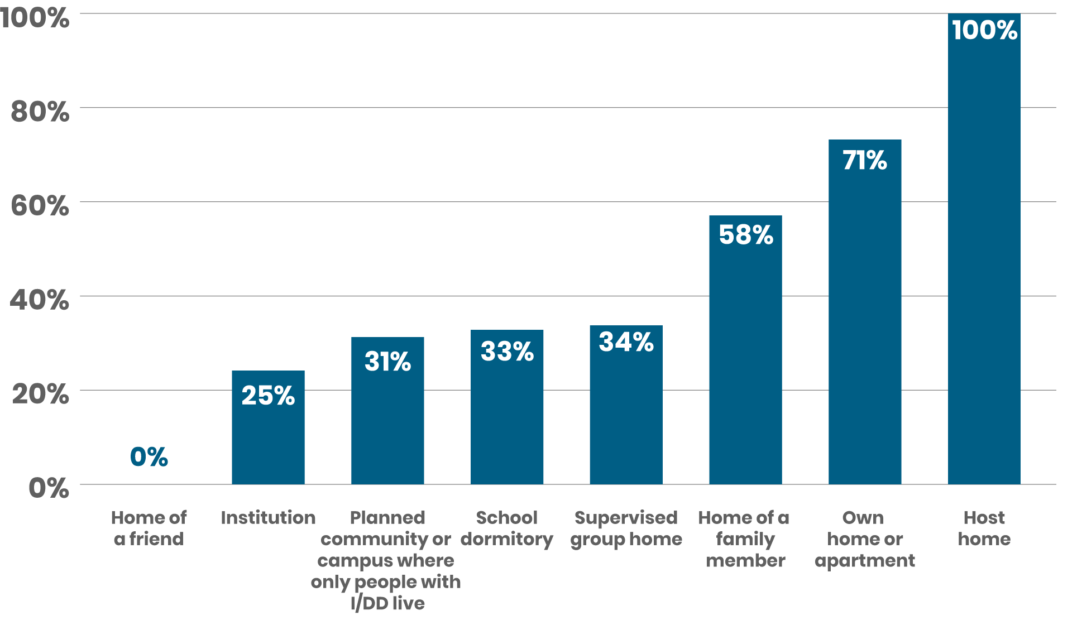

People who lived in host homes, their own home or apartment, or the home of a family member were more likely to choose where to live, who to live with, and what neighborhood to live in.

People who lived with friends, in an institution, or in a planned community or campus where only people with I/DD live were less likely to choose where to live, who to live with, and what neighborhood to
live in.

OTHER FACTORS THAT IMPACTED PEOPLE’S CHOICES
People with I/DD with higher support needs and people with I/DD and mental health disabilities said there were very few community-based housing options for them to choose from.

Most of the time, family members decided where people with I/DD would live. Sometimes, they involved people with I/DD in deciding where they would live, but other times they did not. Most people with I/DD want to be involved in this decision.

WHAT ABOUT FUTURE CHOICES?
People said they didn’t have a lot of options if they wanted to move somewhere else in the future.

FUTURE CHOICES
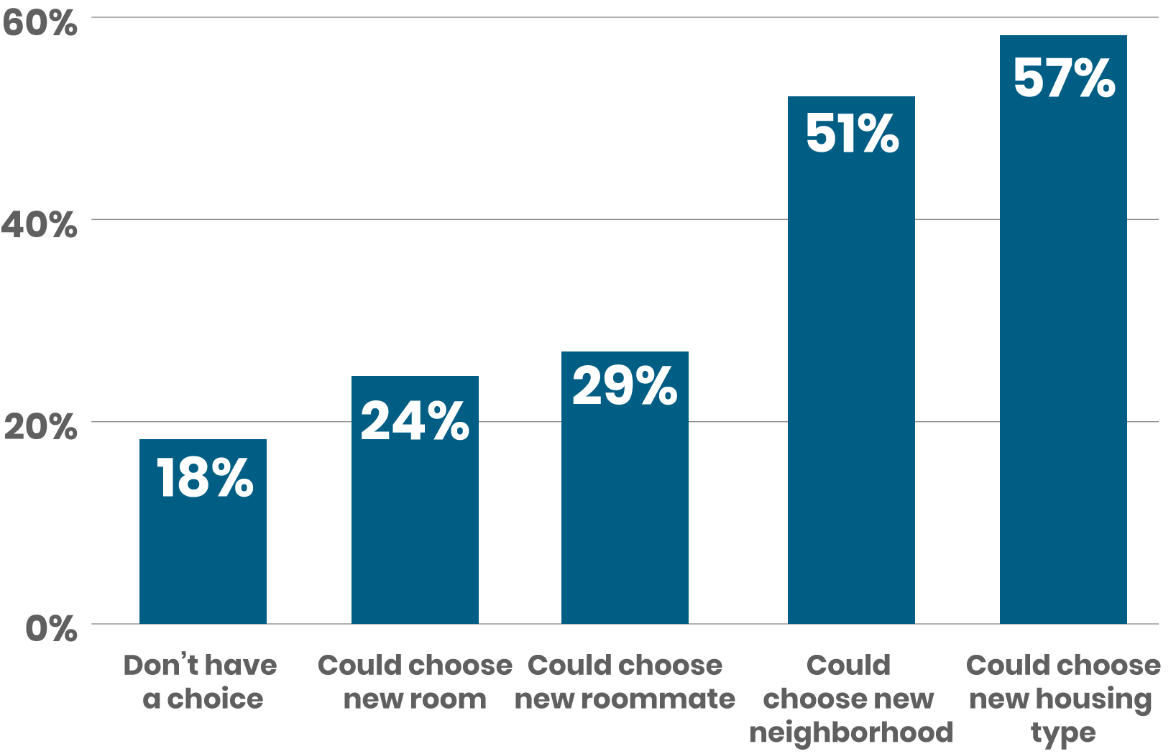
- Many people did not believe they would be able to choose a new room, new roommate, or new housemate.
- Only half of participants believed they would be able to choose a new housing type or a new neighborhood.

WHAT’S THE TAKEAWAY?
People with I/DD want to have choices about where they live, who they live with, and the neighborhood they live in. While not everyone may want, need, or be able to make their own decisions, people with I/DD must be included in decisions about their homes.

